Averaging Filter 1
Sharpen Picture 2
Edge Filtering 3
Edge Direction 4
Edge Detector 5
Detecting Circles 6
Tahoe 7
Building Sample 10

Averaging Filter
A low pass filter in photos eliminates rainbow patters in photos. A lot of extreme details are lost, but the rainbow problem is solved.
clc
img0 = imread('Lena.bmp');
figure(1)
imshow(img0)
img1 = img0(101:200, 101:200);
filt_avg1 = ones(3,3)/9;
img1_LP = uint8(filter2( filt_avg1, img1));
filt_avg2 = ones(3,3)/16;
filt_avg2(2,2) = 0.5;
img1_LP2 = imfilter( img1, filt_avg2 );
figure(2)
subplot(1, 3, 1), imshow(img1), title('Original')
subplot(1, 3, 2), imshow(img1_LP), title('Averaging Filter 1')
subplot(1, 3, 3), imshow(img1_LP2), title('Averaging Filter 2')
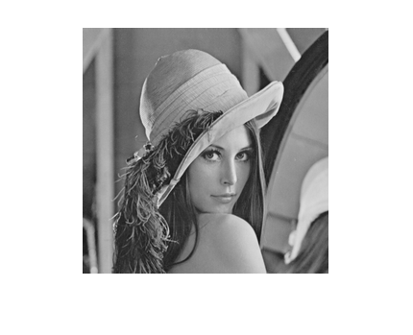
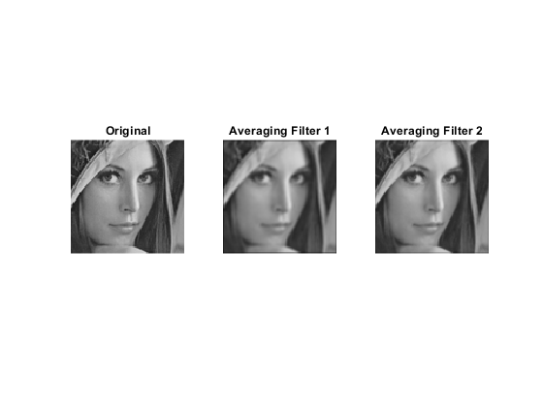

Sharpen Picture
The third line of code removes the values outside the 8 bit range and changes them to uint8.
img1_HP = double(img1) - double(img1_LP);
figure(3)
subplot(1, 2, 1), imshow(img1), title('Original');
axis equal
subplot(1, 2, 2), imshow(img1_HP, []), title('High-pass Filter1'), colorbar
SP_factor = 1; % parameter to control the degree of sharpening
temp = double(img1) + double(img1_HP) * SP_factor;
img1_SP = uint8( (temp > 255) * 255 + (temp >= 0 & temp <= 255) .* temp );
subplot(1, 3, 3), imshow(img1_SP), title('Sharpened')
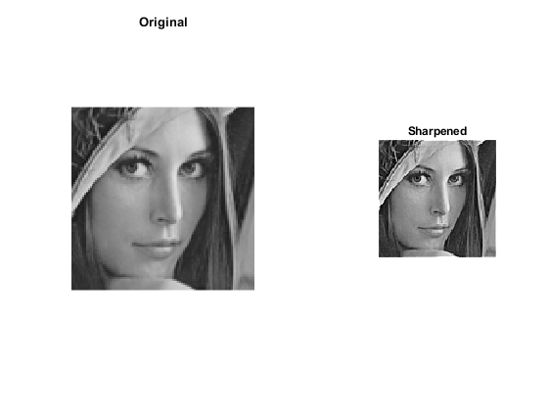

Edge Filtering
%Edge_filter1 looks at the changes in a horizontal direction, while Edge_filter2 looks at changes in a vertical direction.
edge_filt1_1 = [-1, 0, 1; -1, 0, 1; -1, 0, 1]; % "Prewitt" edge filters
edge_filt1_2 = [-1, -1, -1; 0, 0, 0; 1, 1, 1];
img1_edge1_1 = filter2( edge_filt1_1 / 3, img1 ); % apply edge filters
img1_edge1_2 = filter2( edge_filt1_2 / 3, img1 );
img1_edge1_2(1,:) = 0; % handle cases on image border
img1_edge1_1(:, 1) = 0;
img1_edge1_2(size(img1,1),:) = 0;
img1_edge1_1(:, size(img1,2)) = 0;
img1_edge1 = sqrt( double(img1_edge1_1) .^2 + double(img1_edge1_2) .^2 ); % edge strength
edge_th = 40; % threshold of edge strength
figure(4)
subplot(2, 3, 1), imshow(img1), title('Original')
subplot(2, 3, 2), imshow(img1_edge1_1, []), title('After Edge Filter-1'), colorbar
subplot(2, 3, 3), imshow(img1_edge1_2, []), title('After Edge Filter-2'), colorbar
subplot(2, 3, 4), imshow(img1_edge1, []), title('Edge Strength'), colorbar
subplot(2, 3, 5), imshow(img1_edge1 > edge_th, []), title('Thresholded Strength ')
axis equal
subplot(2, 3, 6), st=1; %% visualize edge directions at a selected resolution
quiver(img1_edge1_2( size(img1,1):(-st):1, 1:st:size(img1,2)), img1_edge1_1( size(img1,1):(-st):1, 1:st:size(img1,2)));
axis([1, size(img1,2), 1, size(img1,1) ]), axis off, title('Edge Direction (zoom-in to view)')
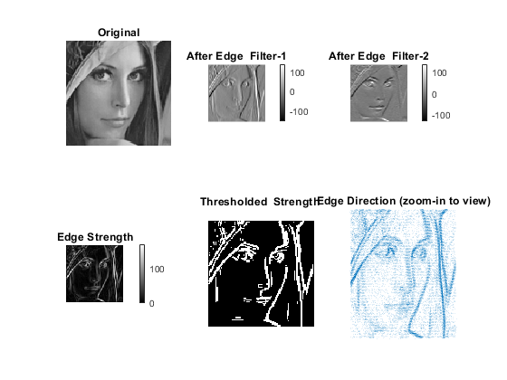

Edge Direction
The arrows are pointing at different directions at different areas of the image. For the lips, they seem to be pointing mostly right, for the eyes, up and down, for the hood, up and down as well, etc.
figure(5)
st = 1;
quiver( img1_edge1_2( size(img1,1):(-st):1, 1:st:size(img1,2)), img1_edge1_1( size(img1,1):(-st):1, 1:st:size(img1,2) ))
axis([1, size(img1,2), 1, size(img1,1) ]), axis off, title('Edge Direction (zoom-in to view)')
edge_filt2_1 = [-1, 0, 1; -2, 0, 2; -1, 0, 1]; % "Sobel" edge filters
edge_filt2_2 = [-1, -2, -1; 0, 0, 0; 1, 2, 1];
img1_edge2_1 = filter2( edge_filt2_1 / 4, img1 ); % apply edge filters
img1_edge2_2 = filter2( edge_filt2_2 / 4, img1 );
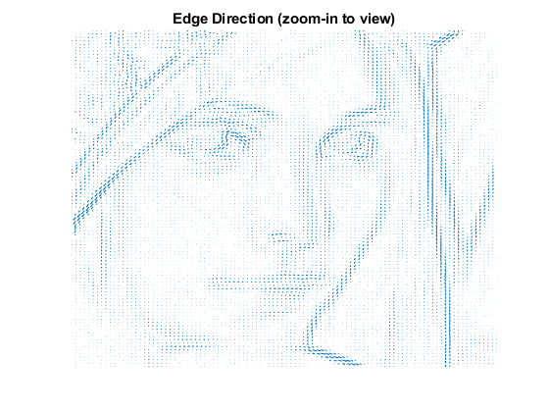

Edge Detector
The image is first converted into grayscale, and then the circles are found by using the imfindcircles tool. It has parameters that can be added, like ‘ObjectPolarity’ and ‘sensitivity’, which was used for finding dark circles. For the lighter ones, the ‘dark’ parameter is changed to ‘light’, and another parameter named ‘Edge Threshold’ is added. You still must play around with the sensitivity value until desired result is found.
img1_edge3 = edge(img1,'sobel');
img1_edge4 = edge(img1,'canny');
figure(6)
subplot(1, 3, 1)
imshow(img1), title('Original')
subplot(1, 3, 2), imshow(img1_edge3), title('Sobel Edge Detector')
subplot(1, 3, 3), imshow(img1_edge4), title('Canny Edge Detector')
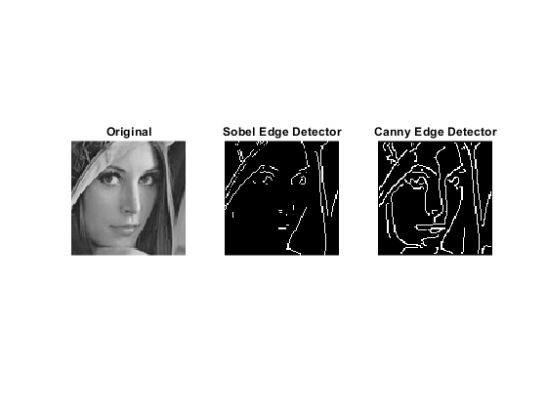

Detecting Circles
figure(7)
rgb = imread('coloredChips.png');
imshow(rgb)
d = imdistline;
delete(d)
gray_image = rgb2gray(rgb);
imshow(gray_image)
[centers,radii] = imfindcircles(rgb,[20 25],'ObjectPolarity','dark');
[centers,radii] = imfindcircles(rgb,[20 25],'ObjectPolarity','dark', 'Sensitivity',0.9);
imshow(rgb)
h = viscircles(centers,radii);
[centers,radii] = imfindcircles(rgb,[20 25],'ObjectPolarity','dark', 'Sensitivity',0.92);
length(centers)
delete(h) % Delete previously drawn circles
h = viscircles(centers,radii);
[centers,radii] = imfindcircles(rgb,[20 25],'ObjectPolarity','dark', 'Sensitivity',0.92,'Method','twostage');
delete(h)
h = viscircles(centers,radii);
[centers,radii] = imfindcircles(rgb,[20 25],'ObjectPolarity','dark', 'Sensitivity',0.95);
delete(h)
viscircles(centers,radii);
imshow(gray_image)
[centersBright,radiiBright] = imfindcircles(rgb,[20 25], 'ObjectPolarity','bright','Sensitivity',0.92);
imshow(rgb)
hBright = viscircles(centersBright, radiiBright,'Color','b');
[centersBright,radiiBright,metricBright] = imfindcircles(rgb,[20 25], 'ObjectPolarity','bright','Sensitivity',0.92,'EdgeThreshold',0.1);
delete(hBright)
hBright = viscircles(centersBright, radiiBright,'Color','b');
h = viscircles(centers,radii);
ans =
16
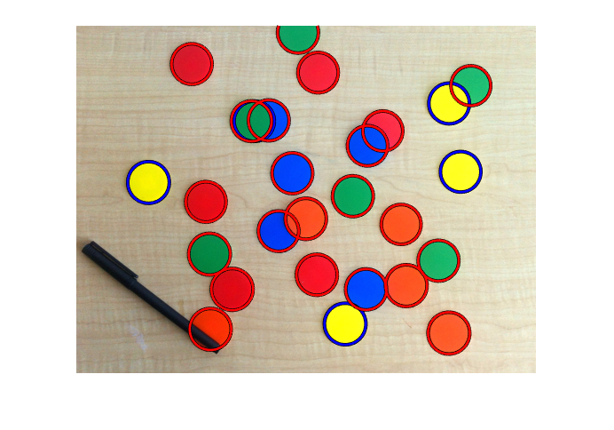

Tahoe
figure(9) % Load images.
buildingScene = imageDatastore('C:\Users\elick\Documents\MATLAB\image processing\Tahoe');
% Display images to be stitched
montage(buildingScene.Files) % Read the first image from the image set.
I = readimage(buildingScene, 1);
% Initialize features for I(1)
grayImage = rgb2gray(I);
points = detectSURFFeatures(grayImage);
[features, points] = extractFeatures(grayImage, points);
% Initialize all the transforms to the identity matrix. Note that the
% projective transform is used here because the building images are fairly
% close to the camera. Had the scene been captured from a further distance,
% an affine transform would suffice.
numImages = numel(buildingScene.Files);
tforms(numImages) = projective2d(eye(3));
% Initialize variable to hold image sizes.
imageSize = zeros(numImages,2);
% Iterate over remaining image pairs
for n = 2:numImages
% Store points and features for I(n-1).
pointsPrevious = points;
featuresPrevious = features;
% Read I(n).
I = readimage(buildingScene, n);
% Convert image to grayscale.
grayImage = rgb2gray(I);
% Save image size.
imageSize(n,:) = size(grayImage);
% Detect and extract SURF features for I(n).
points = detectSURFFeatures(grayImage);
[features, points] = extractFeatures(grayImage, points);
% Find correspondences between I(n) and I(n-1).
indexPairs = matchFeatures(features, featuresPrevious, 'Unique', true);
matchedPoints = points(indexPairs(:,1), :);
matchedPointsPrev = pointsPrevious(indexPairs(:,2), :);
% Estimate the transformation between I(n) and I(n-1).
tforms(n) = estimateGeometricTransform(matchedPoints, matchedPointsPrev, 'projective', 'Confidence', 99.9, 'MaxNumTrials', 2000);
% Compute T(n) * T(n-1) * ... * T(1) tforms(n).
T = tforms(n).T * tforms(n-1).T;
end
% Compute the output limits for each transform
for i = 1:3
[xlim(i,:), ylim(i,:)] = outputLimits(tforms(i), [1 imageSize(i,2)], [1 imageSize(i,1)]);
end
avgXLim = mean(xlim, 2);
[~, idx] = sort(avgXLim);
centerIdx = floor((numel(tforms)+1)/2);
centerImageIdx = idx(centerIdx);
Tinv = invert(tforms(centerImageIdx));
for i = 1:3
tforms(i).T = tforms(i).T * Tinv.T;
end
for i = 1:3
[xlim(i,:), ylim(i,:)] = outputLimits(tforms(i), [1 imageSize(i,2)], [1 imageSize(i,1)]);
end
maxImageSize = max(imageSize);
% Find the minimum and maximum output limits
xMin = min([1; xlim(:)]);
xMax = max([maxImageSize(2); xlim(:)]);
yMin = min([1; ylim(:)]); yMax = max([maxImageSize(1); ylim(:)]);
% Width and height of panorama.
width = round(xMax - xMin);
height = round(yMax - yMin);
% Initialize the "empty" panorama.
panorama = zeros([height width 3], 'like', I);
blender = vision.AlphaBlender('Operation', 'Binary mask', 'MaskSource', 'Input port');
% Create a 2-D spatial reference object defining the size of the panorama.
xLimits = [xMin xMax];
yLimits = [yMin yMax];
panoramaView = imref2d([height width], xLimits, yLimits);
% Create the panorama.
for i = 1:numImages
I = readimage(buildingScene, i);
% Transform I into the panorama.
warpedImage = imwarp(I, tforms(i), 'OutputView', panoramaView);
% Generate a binary mask.
mask = imwarp(true(size(I,1),size(I,2)), tforms(i), 'OutputView', panoramaView);
% Overlay the warpedImage onto the panorama.
panorama = step(blender, panorama, warpedImage, mask);
end
figure
imshow(panorama)
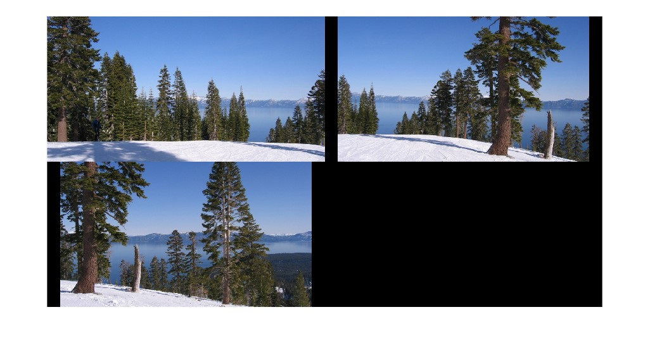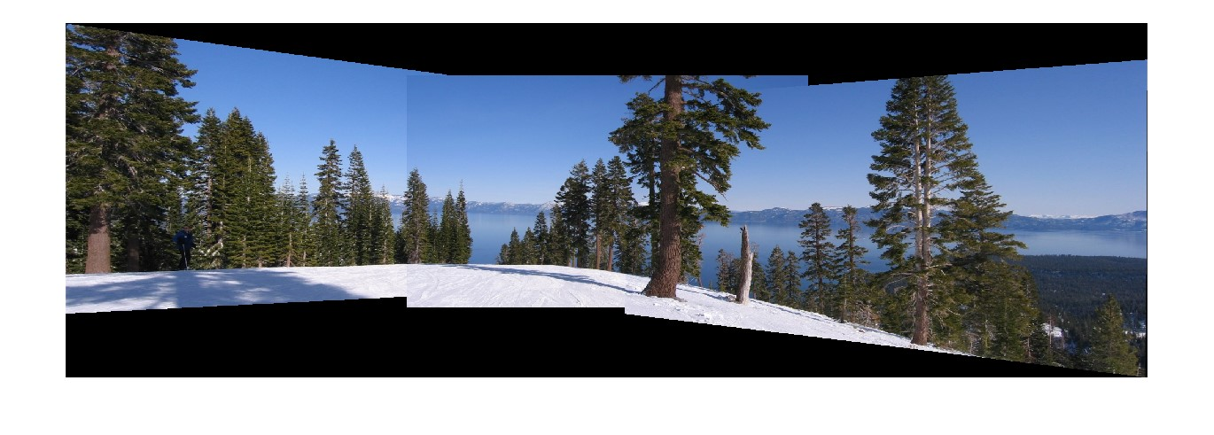

Building Sample
figure(11)
% Load images.
buildingScene = imageDatastore('C:\Users\elick\Documents\MATLAB\image processing\Building');
% Display images to be stitched
montage(buildingScene.Files)
% Read the first image from the image set.
I = readimage(buildingScene, 1);
% Initialize features for I(1)
grayImage = rgb2gray(I);
points = detectSURFFeatures(grayImage);
[features, points] = extractFeatures(grayImage, points);
% Initialize all the transforms to the identity matrix. Note that the
% projective transform is used here because the building images are fairly
% close to the camera. Had the scene been captured from a further distance,
% an affine transform would suffice.
numImages = numel(buildingScene.Files);
tforms(numImages) = projective2d(eye(3));
% Initialize variable to hold image sizes.
imageSize = zeros(numImages,2);
% Iterate over remaining image pairs
for n = 2:numImages
% Store points and features for I(n-1).
pointsPrevious = points;
featuresPrevious = features;
% Read I(n).
I = readimage(buildingScene, n);
% Convert image to grayscale.
grayImage = rgb2gray(I);
% Save image size.
imageSize(n,:) = size(grayImage);
% Detect and extract SURF features for I(n).
points = detectSURFFeatures(grayImage);
[features, points] = extractFeatures(grayImage, points);
% Find correspondences between I(n) and I(n-1).
indexPairs = matchFeatures(features, featuresPrevious, 'Unique', true);
matchedPoints = points(indexPairs(:,1), :);
matchedPointsPrev = pointsPrevious(indexPairs(:,2), :);
% Estimate the transformation between I(n) and I(n-1).
tforms(n) = estimateGeometricTransform(matchedPoints, matchedPointsPrev, 'projective', 'Confidence', 99.9, 'MaxNumTrials', 2000);
% Compute T(n) * T(n-1) * ... * T(1)
tforms(n).T = tforms(n).T * tforms(n-1).T;
end
% Compute the output limits for each transform
for i = 1:numel(tforms)
[xlim(i,:), ylim(i,:)] = outputLimits(tforms(i), [1 imageSize(i,2)], [1 imageSize(i,1)]);
end
avgXLim = mean(xlim, 2);
[~, idx] = sort(avgXLim);
centerIdx = floor((numel(tforms)+1)/2);
centerImageIdx = idx(centerIdx);
Tinv = invert(tforms(centerImageIdx));
for i = 1:numel(tforms)
tforms(i).T = tforms(i).T * Tinv.T;
end
for i = 1:numel(tforms)
[xlim(i,:), ylim(i,:)] = outputLimits(tforms(i), [1 imageSize(i,2)], [1 imageSize(i,1)]);
end
maxImageSize = max(imageSize);
% Find the minimum and maximum output limits xMin = min([1; xlim(:)]); xMax = max([maxImageSize(2); xlim(:)]);
yMin = min([1; ylim(:)]);
yMax = max([maxImageSize(1); ylim(:)]);
% Width and height of panorama.
width = round(xMax - xMin);
height = round(yMax - yMin);
% Initialize the "empty" panorama.
panorama = zeros([height width 3], 'like', I);
blender = vision.AlphaBlender('Operation', 'Binary mask', 'MaskSource', 'Input port');
% Create a 2-D spatial reference object defining the size of the panorama.
xLimits = [xMin xMax];
yLimits = [yMin yMax];
panoramaView = imref2d([height width], xLimits, yLimits);
% Create the panorama.
for i = 1:numImages
I = readimage(buildingScene, i);
% Transform I into the panorama.
warpedImage = imwarp(I, tforms(i), 'OutputView', panoramaView);
% Generate a binary mask.
mask = imwarp(true(size(I,1),size(I,2)), tforms(i), 'OutputView', panoramaView);
% Overlay the warpedImage onto the panorama.
panorama = step(blender, panorama, warpedImage, mask);
end
figure
imshow(panorama)
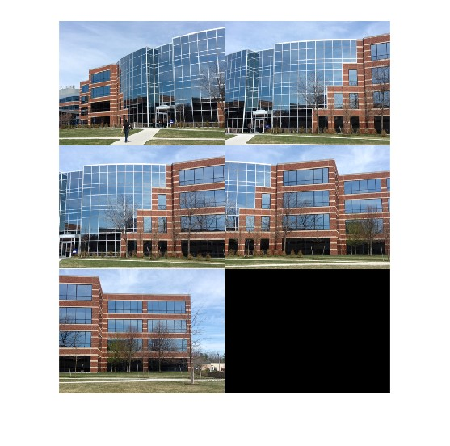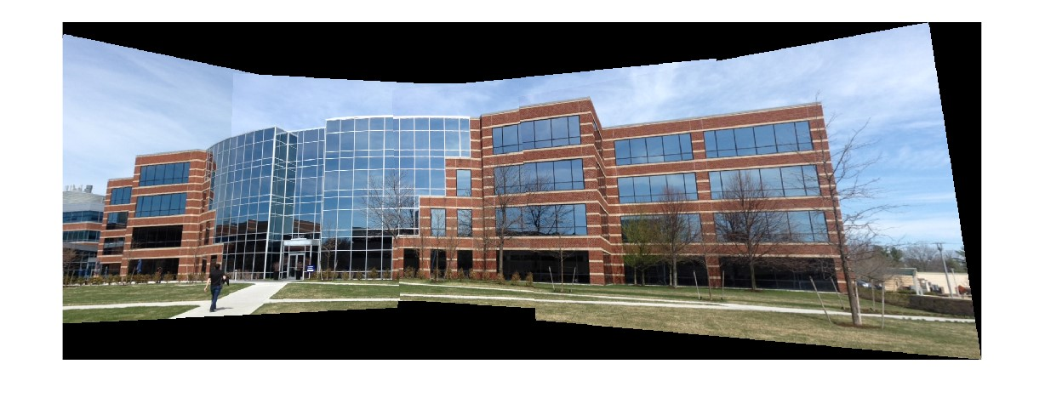

Published with MATLAB® R2022a

